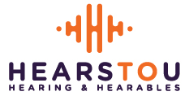

AUTHORIZATION FOR USE AND DISCLOSURE OF INFORMATION

PATIENT RELEASE FORM

This form authorizes ________________________________________________ to release copies of my audiograms to:

HEARS TO U! Audiology
2639 Nicollet Ave S
Minneapolis, MN 55408
TEL: 952-767-0672
FAX: 952-500-9955 (preferred)

Patient Name: __________________________________ Date of Birth: ___________

Address: ______________________________________________________________

Patient Signature: _______________________________________ Date: ___________
(or Legal Guardian / Authorized Representative)

